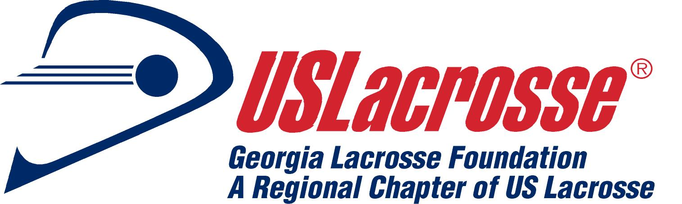

March 18, 2011
XXX
XXX
Atlanta, Georgia 30033

Dear xxxxxx:

The Georgia Lacrosse Officials Association (GLOA) officiate both Georgia High School Association (GHSA) contests and boys youth lacrosse games in North Georgia. Our Association was founded in 2002 and has grown to more than 130 members.

Each year our members raise money for the Ron Mallonee Fund. I am writing to ask for your support as we solicit items to be raffled during our end of the season banquet. 100% of raffle proceeds will go into the Ron Mallonee Fund.

Ron Mallonee Fund
The GLOA has established a scholarship fund in Ron’s memory. The fund assists high school lacrosse players who best exemplify Ron’s selfless attitude towards the game of lacrosse. Since the Ron Mallonee Fund’s inception in 2005, GLOA has been able to provide scholarships to over forty deserving boys from the state of Georgia to attend summer lacrosse camps.

Please send the items you wish to donate to:
Georgia Lacrosse Foundation, Inc. or Georgia Lacrosse Foundation, Inc.
c/o Tom Smith c/o Bob Foster
3749 Markham Way 4726 Outlook Way, NE
Atlanta, GA 30339 Marietta, GA 30066

If you prefer, you can have your donation picked up by contacting our Awards Committee members: Tom Smith (404-245-7711) or Bob Foster (678-770-1485). Should you want a receipt for your donation, upon request the Georgia Lacrosse Foundation will provide you with a letter of acknowledgement including our Internal Revenue Service tax identification information.

Thank you in advance for your consideration of this request.
Sincerely,

GLOA has four main goals:
•To provide game officials for the sport of men’s lacrosse, primarily at the high school level, in the State of Georgia
•To instruct and educate players, coaches, parents, and fans of the sport of lacrosse and the rules governing play
•To train, educate, and certify persons for officiating the sport of men’s lacrosse
•To promote the growth and development of the sport of lacrosse in the State of Georgia

